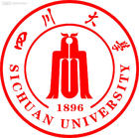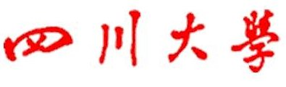
224 south Section 1 Ring Road No.1 ChengDu, SiChuan 610065 P.R.China
Sichuan University

在读证明

兹证明XXX（姓名），XX（性别），学号：XXXXXX，出生年月：XXXX年XX月XX日，经国家统一招生录取，于XXXX年XX月进入我校学习，现为我校XX学院XX专业本科X年级学生，学制X年。我校是中华人民共和国教育部认可的全日制高等学校。
在校期间，该生于XXXX年X月开始在我校XXXX学院修读XXXX专业双学位，目前正在修读中。

四川大学教务处
XXXX年X月X日

224 south Section 1 Ring Road No.1 ChengDu, SiChuan 610065 P.R.China
Sichuan University

CERTIFICATE

To whom it may concern,
This is to certify that XXXX(name), X(gender), Student ID: XXXX, born in：XX (month). XXXX (year)，became an undergraduate student of Sichuan University in September. XXXX (year)，after having passed the National College Entrance Examination. He(She) is now a freshman (Sophomore, Junior or Senior) majoring in XXXX in the college of XXXX of Sichuan University which is a full time university ratified by Education Ministry of the People’s Republic of China.
At the same time, he began to study in the major of XXXX (for dual degree) at the college of XXXX from XX(month),XXXX(year), his study is in the process now.

ACADEMIC AFFAIRS OFFICE OF
SICHUAN UNIVERSITY
DATE ISSUED: XX (month). XXXX (year)

