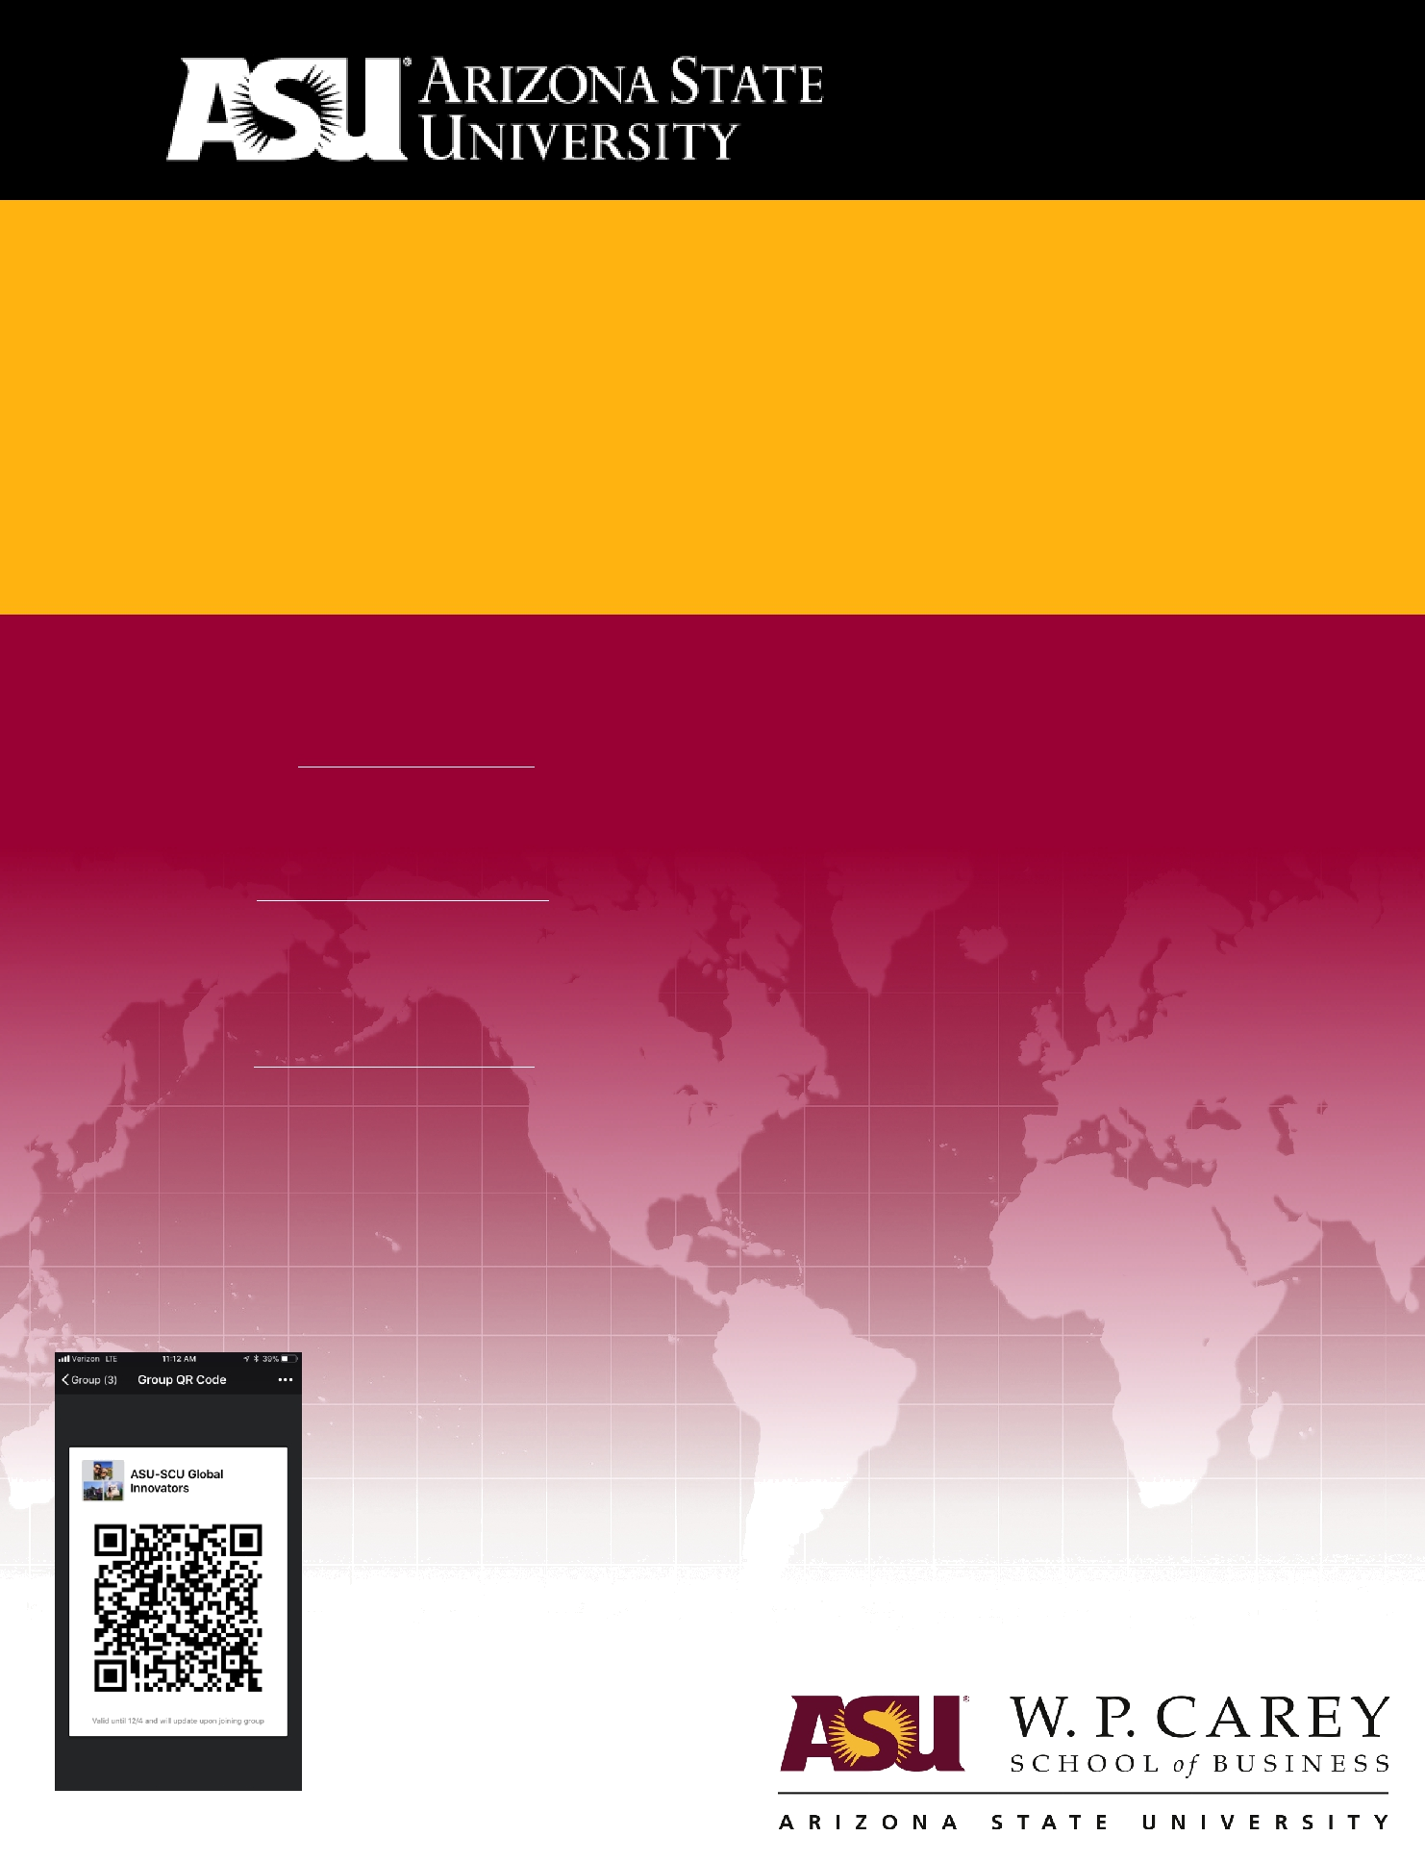

Sichuan University

Global Innovators

January 27th – February 10th, 2018

CONTACTS:

Arizona State University:
Bob Schoenfeld, rschoen@asu.edu
Executive Liaison for International Student Services,

W. P. Carey School of Business, Arizona State University

Angela Zhao, angela.zhao@asu.edu

Senior Project Manager,

Office of the University Provost, Arizona State University

Global Innovators are self-aware professionals with a skill set to participate, contribute and succeed in an international environment. Understanding that English is a tool, cultural awareness is an asset and innovation is the means to global impact, Global Innovators have no comfort zone, accept challenges, promote inclusion and solve problems. Global Innovators make a difference through excellence, awareness and experience.

Global Innovators have global impact.

Contact us with questions!
Summary

Arizona State University and the W. P. Carey School of Business are excited to have the opportunity to be part of the Sichuan University’s endeavors to provide world-class opportunities to their students in the field of entrepreneurship. To help further this goal, we would like to invite

you to this custom-designed Entrepreneurship and Innovation program for university students from Sichuan University. Sichuan “Global Innovators” will be actively engaged in a two-week

program designed to provide entrepreneurial skills, American business English and culture through business instruction. Our goal is to provide business students exposure to real-world

innovation and entrepreneurial opportunities, as well as cultural activities constructed to develop empathy and appreciation for western business strategies, communication skills and an understanding and appreciation of western culture and its effects on the business environment. Participants will engage in workplace observations, team building and mentor activities with local businesses in order to learn best entrepreneurial and innovative practices.

The Center for Entrepreneurship and Innovation and The Global Education Center offer over 60 contact hours of language and business instruction over the program’s two-week schedule.

Introduction to The Center for Entrepreneurship and Innovation

Entrepreneurship is more than nurturing an idea from what if to what is. It’s a lifelong commitment to embracing change, to rethinking the possible, to taking risks you believe in and making others believe in them. The Center for Entrepreneurship at the W. P. Carey School of Business fosters and empowers entrepreneurs in the classroom and across the wider ASU community. We partner with ASU's Office of Knowledge Enterprise Development to offer student entrepreneurs additional entrepreneurial resources to pursue their passion. We work closely with executives and mentors, who share their ideas with the next generation of great entrepreneurs. And we celebrate entrepreneurial Arizona businesses that persevere and create their own success. Whether it’s the next Facebook or simply a better mousetrap, we believe in encouraging ideas and connecting students and start-ups with the resources they need to keep moving forward.

Introduction to The Global Education Center

The Global Education Center implements a student-centered, active learning approach, as opposed to a traditional model where teachers provide content that students are expected to passively absorb. We provide linguistic, academic, social and cultural resources to our international student community. We include team-based activities that not only encourage active, engaged students, but also facilitate peer-to-peer learning. Real life scenarios are embedded in workshops, conversation hours and instruction so that students have an authentic context from which to learn. Students achieve their language and business knowledge — both in skills and confidence — through communicative activities, reflection, and collaboration. Our program curates the best in-class technologies to meet the needs of learners. Participants have ample opportunity to engage with experts in their field and observe the best practices of western business models.

Part I: Program Description

This program utilizes the world-class resources of Arizona State University’s own Center for

Entrepreneurship and the Global Education Center and the W. P. Carey school of Business and local Tempe/Phoenix business owners and professionals to give Sichuan “Global Innovators” an
W. P. Carey School of Business 2
unmatched experience by training with the some of the most innovative business professionals and ESL/EFL practitioners in the country. The Global Education Center is ASU’s platform that propels students, both international and domestic alike, to thrive in the global marketplace. Our approach to business and English education at ASU is innovative, creative and unique. Our engaging and accountable learning approach allows the trainees to draw upon their own experiences as a rich resource for learning, and through internal motivation they are encouraged to solve task or problem-based issues in their own professional and academic lives. W. P. Carey

School of Business faculty, Global Education Center educators and local professionals will work side-by-side with the Sichuan “Global Innovators” through a variety of experiences, not only in the
classroom, but also in the diverse cultural environment of Phoenix, Arizona.

Business, Language and Culture Training

- The participants in this program will be placed into a single classroom for the entrepreneurial experiences, with break out groups that allow for smaller groups interaction for language and cultural awareness. Since dialogue amongst the class is such an intrinsic tool for success in content acquisition, using discussion questions, case studies, and application-oriented activities in a smaller group is essential. In addition, the Global Education Center prides itself on tailored, individualized instruction, so small class size is a key goal in all content-based instruction

- This segment of the program is divided into 3 interrelated components, which increases the knowledge and skillset of the participants in an assortment of topics and subject areas:

  - Component 1: Entrepreneurship & Innovation: Rethink What’s Possible

This section introduces participants into an immersive innovation environment. Through instructor-directed dialogue, group work and pair work, participants learn about cutting edge topics in entrepreneurship and innovation, while gaining further insights into expectations of being a Global Professional. Faculty from the Center of Entrepreneurship use high interest themes to ensure
engagement.
o Global Innovation & Professional Impact 2-week course o Mentoring
o Personal Branding

  - Component 2: Business English & Culture

Afternoon sessions reveal the methodological undercurrents that influence the use of English as a Foreign Language in a globalized business world. A general understanding of western business expectation is outlined, as well as significant approaches toward incorporating strategies to succeed. This course demands participants use their open their minds to concepts and values different from their own and develop their own personal strategies of English language and cultural awareness. Topics of Instruction include:

o Cultural Expectations o Vocabulary
o Professional and Personal Etiquette o Email Etiquette
o Dinner Etiquette
W. P. Carey School of Business 3
  - American English & Culture through TV: Silicon Valley

- Component 3: Engaging with the Professional Business Community

The free and open exchange of ideas with local Chinese and American professionals is essential to the goal of improving participant skillset and becoming a ‘global professional’. This component is comprised of a variety of activities both inside and outside of the classroom; which are designed to help the participants understand intercultural competency, discover new ideas and teaching styles, and gain access to experts in the field amongst other objectives.
  - SkySong
o Decision Theater
o ASU Chandler Innovation Center (ACIC)
o Asian Chamber of Commerce

Part II: Pre-Arrival Activities

Day is a working day. This means all Global Innovators need to be well prepared to participate, contribute and produce on the first day. To accomplish this, Global Innovators engage in a month-long pre-arrival schedule of activities.

Pre-Arrival Engagement

Pre-arrival activities are design to promote engagement and accountability before students arrive at ASU. These activities also allow participants to meet program staff and faculty in order to build relationships and determine expectations.
 | Sunday | Week 1 | Saturday
 |  | Pre-Arrival Engagement
 |  | Activities
WeChat Enrollment; Online Business English Enrollment; Personal Experiences and Goals; Meet the Instructors via WeChat; Entrepreneurship Videos; Q&A

 | Sunday | Week 2 | Saturday
 |  | Pre-Arrival Engagement
Activities
Video: 30-Second Elevator Pitch; Global Professional Questionnaire; Online Business English Module 1;

Entrepreneurship Diagnostic; Q&A

 | Sunday | Week 3 | Saturday
 |  | Pre-Arrival Engagement
Activities

Video Conference (1-on-1 Introductions); Online Business English Module 2; LinkedIn Profile;

Entrepreneurship Ideas & Objectives; Q&A

 | Sunday | Week 4 | Saturday
 |  | Pre-Arrival Engagement
Activity

Linked-In Page Development; Business Language and Culture Diagnostic; Online Business English Module 3;

Entrepreneurial Idea Vetting

 | Arrive 1/27 | January 28th – February 10th | Depart 2/10
 |  | Global Innovators: Tempe, AZ

W. P. Carey School of Business | 4

Part III: Meet your Faculty
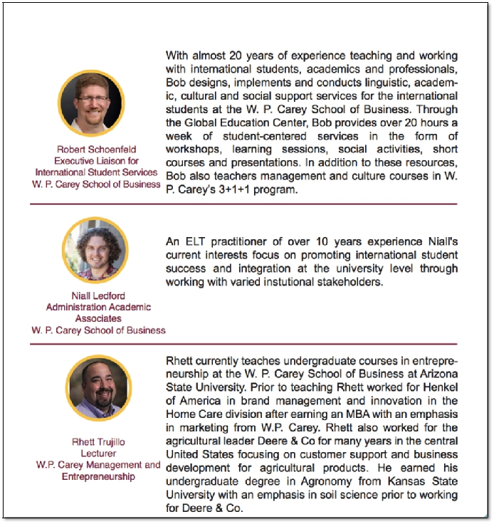

W. P. Carey School of Business | 5

Addendum A: Example Schedule

Stateside Arrival

 | Sunday | Monday | Tuesday | Wed | Thursday | Friday | Saturday
 |  |  |  |  |  | January 26th | January 27th
 |  |  |  |  |  |  | Arrival:
 |  |  |  |  |  |  | Tempe, AZ
 |  |  |  |  |  |  | Check In:
 |  |  |  |  |  |  | Housing
 | Sunday | Monday | Tuesday | Wednesday | Thursday | Friday | Saturday
 | January 28th | January 29th | January 30th | January 31st | February 1st | February 2nd | February 3rd
 | Mornings | Global | Global | Global | Global | Decision | (Optional)
9:00-12:00 |  | Innovation& | Innovation& | Innovation& | Innovation& | Theater | Phoenix
 |  | Professional | Professional | Professional | Professional |  | Cultural
 | Campus Tour | Impact: | Impact: | Impact: | Impact: |  | Activities
 |  | Brainstorming | Researching | Consolidation | Concepting
 | Lunch | AECTV | AECTV | AECTV | AECTV | Business
12:00-2:00 |  | (Optional) | (Optional) | (Optional) | (Optional) | Lunch
 |  |  |  |  |  | Etiquette
 | Welcome | Lecture: | SkySong | Personal | Teamwork I | Global
 | Welcome | ‘Strategic | Tour | Branding |  | Innovation&
 | Ceremony: | from the |  |  |  | Professional
 | Sunday Night | Start’ |  |  |  | Impact:
(6:00-8:00) |  |  | American |  | Email | Prototyping
 |  | GIPI: | Business & | GIPI: | Etiquette I
 |  | Ideation I | Culture I | Ideation II
Sunday | Monday | Tuesday | Wednesday | Thursday | Friday | Saturday
February 4th | February 5th | February 6th | February 7th | February 8th | February 9th | February 10th
Mornings | Global | Global | Global | Global | Presentation | Check out &
9:00-12:00 | Innovation& | Innovation& | Innovation& | Innovation& | Skills | Departure
 | Professional | Professional | Professional | Professional | Workshop I
 | Impact: | Impact: | Impact: | Impact:
 | Revisions | Business | Business | Business
 |  | Model | Model | Model
Lunch | AECTV | AECTV | E&I: | AECTV | AECTV
12:00-2:00 | (Optional) | (Optional) | LinkedIn | (Optional) | (Optional)
 |  |  | Over Lunch
Afternoons | ACIC: | Wrigley Co. | American | GIPI: | GIPI:
2:00-5:00 | Tour | Case Study | Business & | Ideation | Project
 | TechShop |  | Culture II |  | Presentation
Phoenix Suns |  |  |  | Local | & Awards
Basketball |  |  |  | Business | Closing
1:00-4:00 | Dinner | GIPI: |  | Panel/ | Ceremony
 | Etiquette | Ideation III |  | Workshop | (6:00-8:00)
---

---
W. P. Carey School of Business | 6

