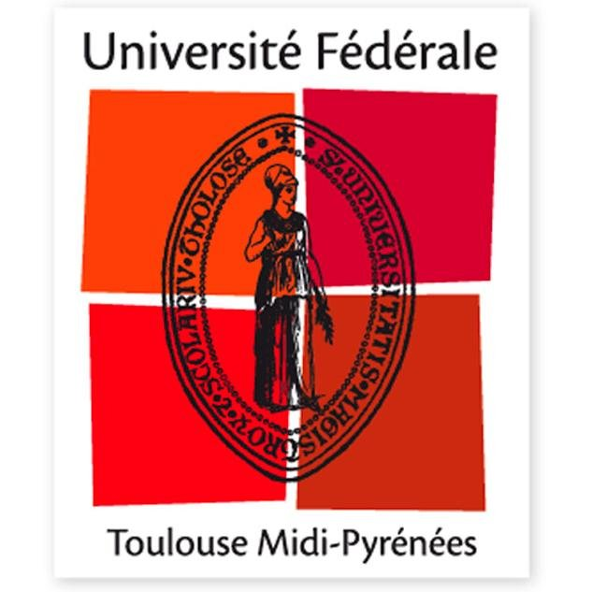

Cultural, Scientific and Technologic Discovery in the European Capital of Aeronautics and Space
Brief description
The Summer School "Cultural, Scientific and Technological Discovery in the European Capital of Aeronautics and Space" will take place from 9 to 22 July 2018 in Toulouse, INP-ENSEEIHT.
Motivation
Toulouse is known as European Capital of Aeronautics and Space thanks to the presence of the headquarters of companies such as AIRBUS, Galileo positioning system, SPOT satellite system, ATR and the Aerospace Valley. The European headquarters of INTEL and CNES's Toulouse Space Centre (CST), the largest space centre in Europe, are also located in Toulouse. Thales Alenia Space and Astrium Satellites (Now part of Airbus Deafens) also have a significant presence in Toulouse.
The University of Toulouse, founded in 1229, is one of the oldest in Europe. With more than 103,000 students, it is the fourth-largest university campus in France, after the universities of Paris, Lyon and Lille. The Toulouse Metro area, with 1,312,304 inhabitants counted in 2014, is France's fourth-largest metropolitan area, after Paris, Lyon and Marseille.
This summer school will be occasion for Chinese students to discover our beautiful Region of Occitanie, the European famous pink city ("Ville Rose" in French), it's wonderful cultural heritage and delicious gastronomy (wines and terror), to attend a major event in the field of Science: the holding of the 8th Edition of the EuroScience Open Forum (ESOF) with Toulouse as THE European City of Science in 2018, to meet French, European or international researchers as well as industrials in the context of Conferences or visits of leading aerospace industry and other French leading research centers.
Description of the summer school
Reception modalities
Arrived in France:
You will arrive on Monday, July 9, 2018 at Toulouse-Blagnac airport where you will be welcomed.
Housing:
You will be housed in the university residences CHAPOU in downtown of Toulouse.
Meals:
Meals are an opportunity to meet and interact with teachers and animators in a more relaxed setting while practicing French. You can enjoy your lunch at the University restaurants in INP-ENSEEIHT campus. The dinners will be taken at the University restaurant of Arsenal from 19:00.
Transports:
The INP-ENSEEIHT is located in the hyper downtown Toulouse, accessible on foot, by metro or by bus from residence CHAPOU. The bus L1 takes 10 minutes from residence CHAPOU to INP-ENSEEIHT. A transport card (pastel card) for metro/bus will be given upon arrival.
Program
1) Discovery of French culture
- Discovery of French culture and French language (12 hours courses).
The program offers 12h of French lessons judiciously distributed throughout the course period. These courses will be taught by teachers from our Institutes for groups of 12-15 students. According to the number of students, the courses can be shared with other Summer School organized at the same period. Classes on French culture will facilitate integration into French daily life. "Ambassadors" (i.e. Chinese engineering students and Chinese PhD students from our Institutes) will be mobilized to help and tutor the neo-coming students during these weeks (during visits for example).
- Cultural visits
Many activities and visits will be offered:
• Monday, July 9: Welcome evening
• Thursday, July 12: Aeroscopia Tour and assembly line of Airbus 380
• Saturday, July 14: Visit of the Cathedral Sainte-Cécile of Albi and visit the vineyards of Gaillacois/
Fireworks on the Garonne river.
• Sunday, July 15: Visit of the “Cité de l'Espace” in Toulouse
• Saturday, July 21: Visit of the medieval city of Carcassonne, listed as a UNESCO World Heritage Site.
2) Scientific and technological discovery
- Conferences and/or visit of leading industrial actors.
Several conferences will be given by industrials in leading companies in their sector, possibly with visits to these companies. We are waiting for representatives of the Airbus and CNES, and also other Toulouse companies to be confirmed later.
- Conferences and visit of leading French research laboratories.
Conferences and laboratory visits will be organized, including Laboratory on Plasma and Conversion of Energy (LAPLACE), Informatics Research Institute of Toulouse (IRIT) and Laboratory for Analysis and Architecture of Systems (LAAS).
- Immersion in teaching practice in French engineering school.
The teaching practices in the learning of one subject in French engineering school will be offered during this summer school.
- Visits to other universities or a engineer schools
Visiting other higher education institutions can be organized according to the interests of the participants. Meeting with Chinese Master students and PhD students at Toulouse University will be organized, and some of them will participate cultural visit and laboratories visit.
Tuition Fee
1000 euros including accommodation, food and excursions
ECTS credits: 2 ECTS credits will offer to each participant.
Deadline: April 30th (??)

