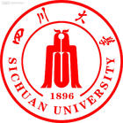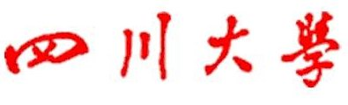
224 south Section 1 Ring Road No.1 ChengDu, SiChuan 610065 P.R.China
Sichuan University
在读证明

XXX（姓名）, X（性别），学号：XXXXXXXXXX, 出生年月：XXXX年XX月XX日。于XXXX年XX月经全国普通高等学校入学考试录取进入我校XXXX学院XXXX专业学习，学制X年，现为本科X年级学生。我校是被中华人民共和国教育部认可的全日制高等学校。

四川大学教务处
X X X X年X X月X X日

Certificate
XXX(name), X (sex), School Code:XXXXXXXXXX, was born in XX(month), XXXX(year), having passed National College Entrance Examination, was enrolled in XXXX school of Sichuan University in September, XXXX(year),majoring in XXXX. The length of schooling is four years. Now he(she) is a Freshman(Sophomore, Junior or Senior). Sichuan University is a full-time accredited school for higher education approved by Education Ministry of the People’s Republic of China.

Dean’s Office of Sichuan University
Date of Certification: XX(month), XXXX(year)

